Generally all the operations on jsp page(.jsp file) takes place when we give request to jsp page. But if want to see certain operations on jsp page should take place during the deployment of web application or during the server startup then we need to enable <load-on-startup> on jsp page.

<Load-on-startup> not enabled:

======================

* First request given to jsp page

Jsp loading

Jsp parsing

Jsp translation(page compilation)

jES loading

JES instantiation

JES initialization

Request processing.

* From second request on wards:

Only Request processing.

Note:: the response of 1st request takes lot of time.

<Load-on-startup> enabled:

======================

* During deployment or during server startup.
* Jsp loading
* Jsp parsing
* Jsp translation(page compilation)
* jES loading
* JES instantiation
* JES initialization
* Request processing.
* Request given to jsp page (First or other than first request)

Directly to request processing.

Note:- The response time of first request is very very less.

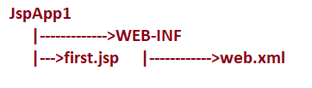

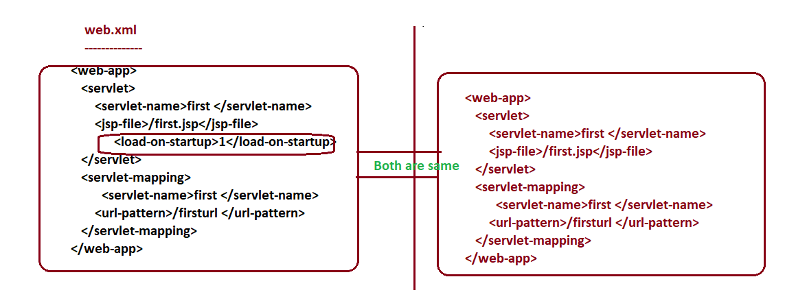

Note:- There is no need of enabling <load-on-startup> on jsp file separately if it is configured in web.xml file mapping with url.